**Geo-thermal-project:**

Check global temperatures for the past 39 years. In case of a Global Warming, the objective is to determine the leading contributing cause.

One hypothesis is the sun is in a moving rotating orbiting motion around the galaxy, the same way earth rotates in a variable orbital velocity and elliptical distance and/or path while performing gravitational orbiting motion around the sun. The shift or even a slight alteration in the revolution distance of earth-round-sun orbit causes the distance from the sun to earth shortened and triggers the increased warming effect on a year to year comparison basis.

Another hypothesis, the warming is caused by lower atmosphere trapped carbon dioxide gasses confining the heat radiation gases to the planets greenhouse, resulting in an increased warming effect.

Another hypothesis, the warming effect is caused by a combination of decreased distances between the sun and trapped greenhouse gasses. The question arises, which one of these factors contributes more to the global warming effect, if such effect even exists.

**Probable causes of possible global Temperature increases could be based/tested on the following relationships:**

* Alternating orbital positioning distance and/or (solar radiation) of sun to earth vs. time
* Alternating carbon emissions presence in atmosphere vs. time
* Orbital Positioning and/or(radiance) vs. Position (Temp)
* Carbon Emissions (CO2) vs. Distance earth-round-the-sun and/or Solar Radiation

**Obtain data sets:**

* Compare the preferable selective identical data with dates starting from: 01-01-1970 and ranging to: 01-01-2019.
* Compare the preferable selective identical data with 4 days in 4 Seasons for each year: Jan 1, Apr 7, July 4 and October 1.
* Compare the preferable selective identical data from a geo-point with the hottest maximum temperature for one of the 4 selected days in a 39-year period and temperatures for each of the 7 continents: North America, South America, Antarctica, Eurasia, Australia and Africa.

## The warmest points for 7 continents: Furnace Creek, Ca, (36.4580° N, 116.8709° W); Rivadavia, Argentina (45.8656° S, 67.4822° W); Esperanza base, Antarctica (63.3981° S, 56.9973° W); Tirat Zvi, Israel (32.4225° N, 35.5283° E); Oodnadatta, Australia( 27.5423° S, 135.4203° E); Kebili, Tunisia (33.7072° N, 8.9715° E)

* Compare the preferable selective identical data from a geo-point with the warmest maximum temperature for one of the 4 selected days in a 39-year period and temperatures for each of the 7 above selected geo-points to the Co2 concentration above each point in the lower atmosphere.

Compare the preferable selective identical data from a geo-point with the warmest maximum temperature for one of the 4 selected days in a 39-year period and temperatures for each of the 7 above selected geo-points to the solar distance and/or solar radiation.

**Obtain types of data sets in a 2nd Scenario (case of missing vital params):**

From 01-01-1970 to 01-01-2019

* Monthly (12 months) Global Average Temperature (Both Hemispheres)
* Monthly (12 months) Global Average Carbon (Co2) concentration in atmosphere
* Monthly (12 months) Average Distance or (radiance levels) earth to sun
* Actual annual full 360 Degree revolution orbital time vs set 365.0 days(Could be measured on month to month) comparison also called Sideral Period. The 360 Degree earths-round-sun orbit time annual fluctuation, could represent the distance fluctuation between a planet and a star. (Cannot find any present data)

Data ranges are preferred to remain set. In case of the source, the data set search parameters are able to match one another. Example: in case data in one of the sets becomes limited on dates with the available range starting 01-01-1978(instead of 01-01-1970); all other data sets, have to adjust and cross-reference 01-01-1978

**Here is one link** to Solar Positioning Algorithm, may help estimate sun/earth distance and the environment code is available for Python, I do want to look for additional sources as this link is offered by National Renewable Energy Lab, the formulation maybe biased. But for the sake of our limited resources and timely constraints, it can become useful.

Fraunhofer Institute for Solar Energy Systems ISE

The algorithm with the highest accuracy should be the Solar Position Algorithm (SPA) by the National Renewable Energy Laboratory (NREL) of the US.

A paper describing the algorithm is available from

[http://rredc.nrel.gov/solar/codesandalgorithms/spa/](https://www.researchgate.net/deref/http%3A%2F%2Frredc.nrel.gov%2Fsolar%2Fcodesandalgorithms%2Fspa%2F)

The code (written in C) is available from the same website after a registration.

(The paper is also available on researchgate:

<https://www.researchgate.net/publication/222533716_Solar_position_algorithm_for_solar_radiation_applications?)>

There are free versions in other programming languages available too:

Python: [http://pysolar.org/](https://www.researchgate.net/deref/http%3A%2F%2Fpysolar.org%2F)

Matlab: [http://pvpmc.org/pv-lib/](https://www.researchgate.net/deref/http%3A%2F%2Fpvpmc.org%2Fpv-lib%2F)

An online calculator is available here:

[https://www.nrel.gov/midc/solpos/spa.html](https://www.researchgate.net/deref/https%3A%2F%2Fwww.nrel.gov%2Fmidc%2Fsolpos%2Fspa.html)

**World Meteorological Organization(WMO) site:**

[**https://www.wmo.int/cpdb/**](https://www.wmo.int/cpdb/)

**Link to NASA data sets:**

<https://www.giss.nasa.gov/>

**Link to US Navy geocentric position, it is private, no access:**

<https://aa.usno.navy.mil/data/docs/geocentric.php>

Geocentric perihelion distance 2010 - 2026  
computed by MICA (Multiyear Interactive Computer Almanac by US Naval Observatory)

|  |  |  |
| --- | --- | --- |
| 2010 - 2026 | Distance / AU | Distance / km |
| Mean | 0.983,299,155 | 147.099,459 |
| Minimum | 0.983,243,565 | 147,091,143 |
| Maximum | 0.983,341,273 | 147,105,760 |
| Max. - Min. | 0,000,097,708 | 14,617 |
| (Max-Min)/Mean | 0.010 % | |
| Stand. Dev. | 0.000,026,692 | 3.993 |
| Stand. Dev. | 0.0029 % | |

**Link to NASA Solar Radiation and Mereological Data set:**

[**https://power.larc.nasa.gov/data-access-viewer/**](https://power.larc.nasa.gov/data-access-viewer/)

[**https://data.nasa.gov/Earth-Science/Surface-Meteorology-and-Solar-Energy/wn3p-qsan**](https://data.nasa.gov/Earth-Science/Surface-Meteorology-and-Solar-Energy/wn3p-qsan)

**World Weather Online, weather datasets:**

[**Worldweatheronline.com**](https://www.worldweatheronline.com/developer/api/)

**Total Solar Irradiance** (TSI) is a measure of the [solar power](https://en.wikipedia.org/wiki/Solar_power) over all wavelengths per unit area incident on the Earth's [upper atmosphere](https://en.wikipedia.org/wiki/Upper_atmosphere).

**Historical reconstructions**:  The two key datasets for long, historical records of TSI are (1) SATIRE and (2) NRLTSI. The NRLTSI data are being produced by NOAA as a Climate Data Record, available in a useful netCDF format with data for 1882-present.

For **CMIP6** historical experiments, the recommended solar forcing data (see "Get Data" tab for access) are based on a mean of these historical reconstructions.

The solar radiation arriving at Earth (once known as the “solar constant”, now usually referred to as **Total Solar Irradiance (TSI))**

The primary source of energy to the Earth is radiant energy from the Sun. This radiant energy is measured and reported as the solar irradiance.

**Contemporary radiometric measurements from satellites**:  Recently, TSI has been measured by the Total Irradiance Monitor (TIM); two versions of this instrument have flown on the SORCE spacecraft (providing TSI measurements since 2003) and the TCTE platform (providing TSI measurements since 2013).  SORCE and TCTE data are available through the University of Colorado's Laboratory for Atmospheric and Space Physics.

________________________________________________________________________________

**Albedo:** is the measure of the [diffuse reflection](https://en.wikipedia.org/wiki/Diffuse_reflection) of [solar radiation](https://en.wikipedia.org/wiki/Sunlight) out of the total [solar radiation](https://en.wikipedia.org/wiki/Solar_radiation) received by an [astronomical body](https://en.wikipedia.org/wiki/Astronomical_body),

Surface albedo is defined as the ratio of irradiance reflected to the irradiance received by a surface.

Albedo refers to the entire spectrum of solar radiation.

Albedo affects [climate](https://en.wikipedia.org/wiki/Climate) by determining how much [radiation](https://en.wikipedia.org/wiki/Radiation) a planet absorbs.

Proposed solar radiation management using a tethered balloon to inject sulfate aerosols into the stratosphere.

The proportion reflected is not only determined by properties of the surface itself, but also by the spectral and angular distribution of solar radiation reaching the Earth's surface.[[1]](https://en.wikipedia.org/wiki/Albedo#cite_note-1)These factors vary with atmospheric composition, geographic location and time (see [position of the Sun](https://en.wikipedia.org/wiki/Position_of_the_Sun)). While bi-hemispherical [reflectance](https://en.wikipedia.org/wiki/Reflectance) is calculated for a single angle of incidence.

LSA is an essential variable linking the land surface and the climate system. It is a unique property for studying how land surface changes affect the energy balance and the overall climate system.

**Suomi National Polar-orbiting Partnership** or **Suomi NPP**, previously known as the **National Polar-orbiting Operational Environmental Satellite System Preparatory Project**(**NPP**) and **NPP-Bridge**, is a [weather satellite](https://en.wikipedia.org/wiki/Weather_satellite) operated by the [United States](https://en.wikipedia.org/wiki/United_States) [National Oceanic and Atmospheric Administration](https://en.wikipedia.org/wiki/National_Oceanic_and_Atmospheric_Administration).

**NPOESS Preparatory Project (NPP)** is intended to bridge the gap between old [EOS](https://en.wikipedia.org/wiki/Earth_Observing_System) and new systems by flying new instruments, on a new satellite bus, using a new ground data network.

Suomi NPP is the first in a new generation of satellites intended to replace the System satellites, which were launched from 1997 to 2011. The satellite orbits the Earth about 14 times each day.

**Its five imaging systems include:**

* Advanced Technology Microwave Sounder (ATMS),[[15]](https://en.wikipedia.org/wiki/Suomi_NPP#cite_note-15) a [microwave radiometer](https://en.wikipedia.org/wiki/Microwave_radiometer) which will help create global moisture and temperature models
* Cross-track Infrared Sounder (CrIS),[[16]](https://en.wikipedia.org/wiki/Suomi_NPP#cite_note-16) a [Michelson interferometer](https://en.wikipedia.org/wiki/Michelson_interferometer) to monitor moisture and pressure
* [Ozone Mapping and Profiler Suite](https://en.wikipedia.org/wiki/Ozone_Mapping_and_Profiler_Suite) (OMPS),[[17]](https://en.wikipedia.org/wiki/Suomi_NPP#cite_note-17) a group of [imaging spectrometers](https://en.wikipedia.org/wiki/Imaging_spectrometer) to measure ozone levels, especially near the poles
* [Visible Infrared Imaging Radiometer Suite](https://en.wikipedia.org/wiki/Visible_Infrared_Imaging_Radiometer_Suite) (VIIRS),[[18]](https://en.wikipedia.org/wiki/Suomi_NPP#cite_note-18) a 22-band [radiometer](https://en.wikipedia.org/wiki/Radiometer) to collect infrared and visible light data to observe weather, climate, oceans, nightlight, wildfires, movement of ice, and changes in vegetation and landforms
* [Clouds and the Earth's Radiant Energy System](https://en.wikipedia.org/wiki/Clouds_and_the_Earth%27s_Radiant_Energy_System) (CERES), a radiometer to detect thermal radiation, including reflected solar radiation and thermal radiation emitted by the Earth

__________________________________________________________________________

**Global Warming Proponent:**

The mechanism by which carbon dioxide traps heat in the atmosphere is commonly referred to as the "greenhouse effect."  Stated very simply, carbon dioxide, or CO2, is nearly transparent to the solar radiation emitted from the sun, but partially opaque to the thermal radiation emitted by the earth.  As such, it allows incoming solar radiation from the sun to pass through it and warm the earth's surface.  The earth's surface, in turn, emits a portion of this energy upwards toward space as longer wavelength or thermal radiation.  Some of this thermal radiation is absorbed and re-radiated by the atmosphere's CO2 molecules back toward earth's surface, providing an additional source of heat energy.  Without water vapor, CO2, and other radiatively-active trace gases in the air, the planet's average temperature would be about 34°C cooler than it is at present.

**Thermal radiation** is electromagnetic **radiation** emitted from a material that is due to the **heat** of the material, the characteristics of which depend on its temperature.

## Effect of Earth’s atmosphere on incoming solar radiation:

<https://eesc.columbia.edu/courses/ees/climate/lectures/radiation_hays/>

**Atmospheric Opacity:**  
Radiation detected by satellites is comprised of both terrestrial and atmospheric sources, however, [**energy from the earth's surface must travel through the atmosphere**](javascript:;) before it reaches the satellite. Satellite sensors are designed to be particularly sensitive to those wavelengths of radiant energy that can be reflected or emitted back up through the atmosphere to space. By using the [**laws of radiation**](javascript:;) to calibrate radiometers and interpret details displayed on satellite images, scientists can measure the height, temperature, moisture content (and more) about nearly every feature of the earth’s atmosphere, hydrosphere, lithosphere, and biosphere.

<https://cimss.ssec.wisc.edu/sage/remote_sensing/lesson2/concepts.html>

NASA DATA SOURCE: CLICK on dropdown find DAAC lots of links

<https://search.earthdata.nasa.gov/search?m=5.90625!52.3125!0!1!0!0%2C2&fst0=Atmosphere>

Alaska Satellite Facility:

<https://vertex.daac.asf.alaska.edu/>

Modis Satellite NASA:

<https://ladsweb.modaps.eosdis.nasa.gov/validation/atmosphere/>

### The Atmosphere’s Energy Budget link:

<https://eosweb.larc.nasa.gov/radiation-budget>

**Energy Budget Articles:**

<https://earthobservatory.nasa.gov/features/EnergyBalance/page6.php>

<https://www.earthobservatory.nasa.gov/features/EnergyBalance/page4.php>

**Earths energy budget:**[**https://upload.wikimedia.org/wikipedia/commons/b/bb/The-NASA-Earth%27s-Energy-Budget-Poster-Radiant-Energy-System-satellite-infrared-radiation-fluxes.jpg**](https://upload.wikimedia.org/wikipedia/commons/b/bb/The-NASA-Earth%27s-Energy-Budget-Poster-Radiant-Energy-System-satellite-infrared-radiation-fluxes.jpg)

**OLRdata:**[**https://www.google.com/amp/s/www.researchgate.net/post/What_are_the_main_sources_to_download_outgoing_longwave_radiation_OLR_datasets/amp**](https://www.google.com/amp/s/www.researchgate.net/post/What_are_the_main_sources_to_download_outgoing_longwave_radiation_OLR_datasets/amp)

**Ceres Satellite Energy Budget Monitoring:**[**https://ceres.larc.nasa.gov/**](https://ceres.larc.nasa.gov/)

**OLR definition:**

[**https://en.m.wikipedia.org/wiki/Outgoing_longwave_radiation**](https://en.m.wikipedia.org/wiki/Outgoing_longwave_radiation)

**Satellite Monitoring: Nasa**

CERES:  
<https://en.m.wikipedia.org/wiki/Clouds_and_the_Earth%27s_Radiant_Energy_System>

ERBS:<https://en.m.wikipedia.org/wiki/Earth_Radiation_Budget_Satellite>Earth Energy Budget: <https://en.m.wikipedia.org/wiki/Earth%27s_energy_budget>

Solar Insolation Data Set Solar 1983-2005:

<https://neo.sci.gsfc.nasa.gov/view.php?datasetId=CERES_INSOL_M>

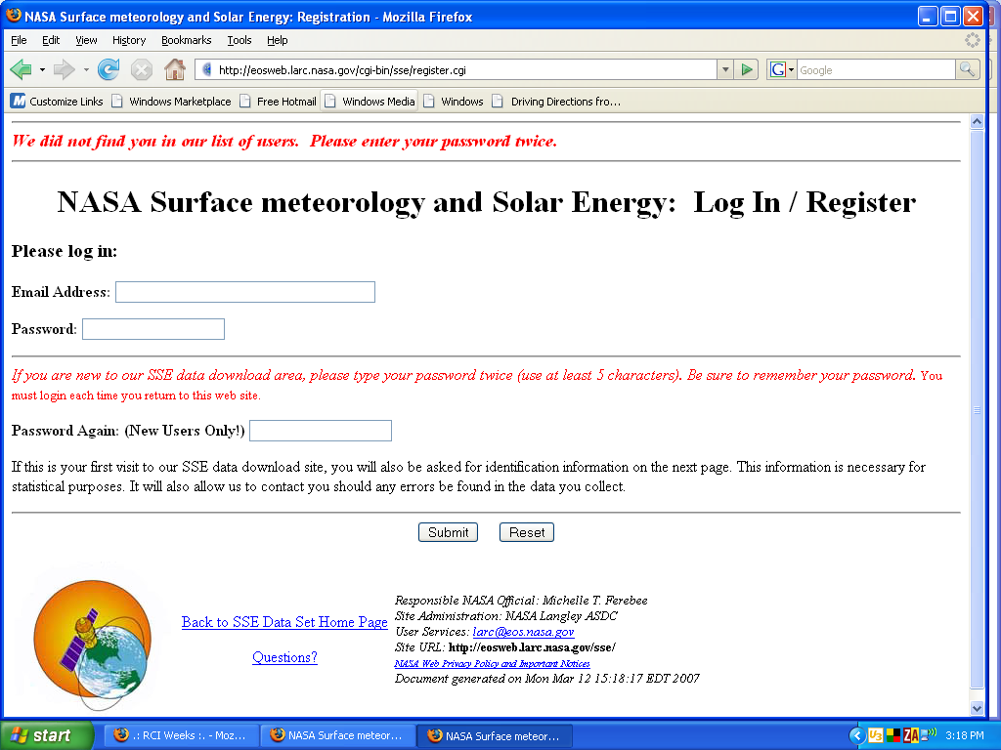

**Registration Complete to pull Data.**

**Some additional research. I would like for the Data Sets to come from the government funded programs: NASA, NOAA etc.**

**Search for:**

Solar Radiation

Infrared Wavelengths

OLR(Outgoing Longwave Radiation)

Solar insolation (NASA)

Nasa Solar Irradiance

Solar Radiation

Solar Spectral Irradiance

Albedo

Atmosphere Energy Budget or Energy Budget

**Aerosol Proponent article:**  
<http://www1.uni-frankfurt.de/forschung/profil/sfbs/sfb641/Publikationen/pdf/C2/P__schl_AngewChemIntEd2005_Aerosol.pdf>

**Aerosol Nasa:**

<https://climate.nasa.gov/climate_resources/146/video-simulated-clouds-and-aerosols/>

**Earth to Sun modern approximation method:**

<http://curious.astro.cornell.edu/about-us/41-our-solar-system/the-earth/orbit/87-how-do-you-measure-the-distance-between-earth-and-the-sun-intermediate>

**Satellite probe to orbit the sun, Aug 2018:**

<https://science.howstuffworks.com/how-close-can-get-to-sun.htm>

# **How can we compute solar position at a given place on a given day and time:**

<https://www.researchgate.net/post/How_can_we_compute_solar_position_at_a_given_place_on_a_given_day_and_time>

**NASA Satellite Imaging Observations on Carbon Dioxide in Layers of Atmosphere since 2002:**

<https://climate.nasa.gov/vital-signs/carbon-dioxide/>

<https://climate.nasa.gov/vital-signs/global-temperature/>

<https://www.co2.earth/co2-monitoring>

CO2.Earth mainly features CO2 data from measurements made by two scientific institutions at the **Mauna Loa Observatory (MLO)** on the Big Island of Hawaii USA: the National Atmospheric and Oceanic Administration (NOAA) and Scripps Institution of Oceanography (SIO).

**Mauna Loa Observatory(MLO)**

<https://www.esrl.noaa.gov/gmd/obop/mlo/>

Mauna Loa Observatory (MLO) is a premier atmospheric research facility that has been continuously monitoring and collecting data related to atmospheric change since the 1950's. The undisturbed air, remote location, and minimal influences of vegetation and human activity at MLO are ideal for monitoring constituents in the atmosphere that can cause climate change.

## Missions that observe CO2 :

## <https://co2.jpl.nasa.gov/>

## LIST OF ALL SATELLITES AND GROUND BASED Programs:

## [ACOS(GOSAT)](http://www.gosat.nies.go.jp/en/about_3_analysis.html) MEASUREMENT METHOD:

GOSAT observes infrared light reflected and emitted from the earth's surface and the atmosphere. Column abundances of CO2 and CH4 are calculated from the observational data. The column abundance of a gas species is expressed as the number of the gas molecules in a column above a unit surface area.

The molecules of CO2 and CH4 in the atmosphere absorb light of particular wavelengths. Hence, the amounts of CO2 and CH4 in an optical path can be calculated through measuring how much light is absorbed by these molecules.

[Atmospheric Infrared Sounder (AIRS)](https://airs.jpl.nasa.gov/)

**Microwave AIRS measures atmospheric temps:**

The Atmospheric Infrared Sounder, AIRS, was launched aboard the Aqua space-craft in 2002 as part of NASA's Earth Observing System Afternoon Constellation of satellites in a sun-synchronous polar orbit known as the A-Train. AIRS thermal infrared hyperspectral observations are used to retrieve temperature and water vapor profiles, and numerous trace gases including carbon dioxide, ozone, carbon monox- ide, and methane. AIRS data improve weather prediction, validate climate models, and improve our understanding of the processes affect- ing weather and climate and the global transport of greenhouse gases worldwide.

<https://airs.jpl.nasa.gov/mission_and_instrument/overview>

[Orbiting Carbon Observatory (OCO-2)](http://oco.jpl.nasa.gov/)

**ABOUT OCO-2 LATEST ONE July 2014 LAUNCHED**

The Orbiting Carbon Observatory, OCO-2, will be NASA’s first dedicated Earth remote sensing satellite to study atmospheric carbon dioxide from Space. OCO-2 will be collecting space-based global measurements of atmospheric CO2 with the precision, resolution, and coverage needed to characterize sources and sinks on regional scales. OCO-2 will also be able to quantify CO2 variability over the seasonal cycles year after year.

Rather than directly measuring concentrations of carbon dioxide in the atmosphere, OCO-2 records how much of the sunlight reflected off the Earth is absorbed by CO2 molecules in an air column.

[TES(AURA)](https://aura.gsfc.nasa.gov/tes.html)

<https://aura.gsfc.nasa.gov/tes.html>

TES is a high-resolution infrared-imaging Fourier transform spectrometer offers a line-width-limited discrimination of essentially all radiatively active molecular species in the Earth's lower atmosphere.

<https://www.jpl.nasa.gov/news/news.php?feature=7061>

The Tropospheric Emission Spectrometer, TES, is the first satellite instrument to provide simultaneous concentrations of carbon monoxide, ozone, water vapor and methane throughout Earth’s lower atmosphere. This is also where gases such as ozone (O3) are formed, transported, and interact with other gases, and where much of the atmospheric water cycle is dictated. Understanding the distribution and movement of these and other trace gases is vital if we are to understand and correctly represent climate and air quality.

<https://en.wikipedia.org/wiki/Infrared_atmospheric_sounding_interferometer>

NOAA-NASA Suomi-NPP satellite and the Infrared Atmospheric Sounding Interferometer (IASI) series, developed by the French space agency in partnership with EUMETSAT, the European meteorological satellite organization.

<https://en.wikipedia.org/wiki/Michelson_interferometer>

<https://en.wikipedia.org/wiki/Interferometry>

[TCCON(ground based measurements)](http://www.tccon.caltech.edu/)

**TCCON** is a network of ground-based Fourier Transform Spectrometers recording direct solar spectra in the near-infrared spectral region. From these spectra, accurate and precise column-averaged abundance of CO2, CH4, N2O, HF, CO, H2O, and HDO are retrieved.   
  
TCCON provides an essential validation resource for the [Orbiting Carbon Observatory](http://oco.jpl.nasa.gov/) (OCO), [Sciamachy](http://envisat.esa.int/instruments/sciamachy), and [GOSAT](http://www.jaxa.jp/projects/sat/gosat/index_e.html).

<https://en.wikipedia.org/wiki/Fourier-transform_spectroscopy>

**Fourier-transform spectroscopy** is a measurement technique whereby spectra are collected based on measurements of the [coherence](https://en.wikipedia.org/wiki/Coherence_(physics)) of a [radiative](https://en.wikipedia.org/wiki/Radiation) source, using [time-domain](https://en.wikipedia.org/wiki/Time-domain) or space-domain measurements of the [electromagnetic radiation](https://en.wikipedia.org/wiki/Electromagnetic_radiation) or other type of radiation. It can be applied to a variety of types of spectroscopy including [optical spectroscopy](https://en.wikipedia.org/wiki/Optical_spectroscopy), [infrared spectroscopy](https://en.wikipedia.org/wiki/Infrared_spectroscopy)([FTIR](https://en.wikipedia.org/wiki/Fourier-transform_infrared_spectroscopy), FT-NIRS), [nuclear magnetic resonance](https://en.wikipedia.org/wiki/Nuclear_Magnetic_Resonance_Spectroscopy) (NMR) and magnetic resonance spectroscopic imaging (MRSI),[[](https://en.wikipedia.org/wiki/Fourier-transform_spectroscopy#cite_note-1)

One of the most basic tasks in [spectroscopy](https://en.wikipedia.org/wiki/Spectroscopy) is to characterize the [spectrum](https://en.wikipedia.org/wiki/Spectrum) of a light source: how much light is emitted at each different wavelength. The most straightforward way to measure a spectrum is to pass the light through a [monochromator](https://en.wikipedia.org/wiki/Monochromator), an instrument that blocks all of the light *except* the light at a certain wavelength (the un-blocked wavelength is set by a knob on the monochromator). Then the intensity of this remaining (single-wavelength) light is measured.

[**Stationary-wave integrated Fourier transform spectrometry (SWIFTS)**](https://en.wikipedia.org/wiki/Stationary-wave_integrated_Fourier_transform_spectrometry) is an analytical technique used for measuring the distribution of light across an [optical spectrum](https://en.wikipedia.org/wiki/Visible_spectrum). SWIFTS technology is based on a [near-field](https://en.wikipedia.org/wiki/Near-field_optics) [Lippmann](https://en.wikipedia.org/wiki/Gabriel_Lippmann) architecture. An optical signal is injected into a [waveguide](https://en.wikipedia.org/wiki/Waveguide) and ended by a mirror (true Lippman configuration). The input signal interferes with the reflected signal, creating a [stationary wave](https://en.wikipedia.org/wiki/Stationary_wave).

<https://www.nasa.gov/mission_pages/oco2/index.html>

# **Satellite Observatory uses Advanced microwave sounding unit:**

<https://en.wikipedia.org/wiki/Advanced_microwave_sounding_unit>

The instrument examines several bands of microwave radiation from the atmosphere to **perform**[**atmospheric sounding**](https://en.wikipedia.org/wiki/Atmospheric_sounding) of temperature and moisture levels.:

An **atmospheric sounding** is a measurement of vertical distribution of physical properties of the [atmospheric](https://en.wikipedia.org/wiki/Atmosphere) column such as [pressure](https://en.wikipedia.org/wiki/Atmospheric_pressure), [temperature](https://en.wikipedia.org/wiki/Temperature), [wind speed](https://en.wikipedia.org/wiki/Wind_speed) and [wind direction](https://en.wikipedia.org/wiki/Wind_direction) (thus deriving [wind shear](https://en.wikipedia.org/wiki/Wind_shear)), liquid water content, [ozone](https://en.wikipedia.org/wiki/Ozone) concentration, pollution, and other properties. Such measurements are performed in a variety of ways including [remote sensing](https://en.wikipedia.org/wiki/Remote_sensing) and sit observations.

https://en.wikipedia.org/wiki/Microwave

<https://science.nasa.gov/ems/06_microwaves>

<https://www.eumetsat.int/website/home/Satellites/CurrentSatellites/Metop/MetopDesign/AMSUA/index.html>

<https://en.wikipedia.org/wiki/Infrared>

<https://en.wikipedia.org/wiki/Radiometer>

A **radiosonde** is a battery-powered [telemetry](https://en.wikipedia.org/wiki/Telemetry) instrument carried into the atmosphere usually by a [weather balloon](https://en.wikipedia.org/wiki/Weather_balloon) that measures various [atmospheric parameters](https://en.wikipedia.org/wiki/Atmospheric_sounding) and transmits them by radio to a ground receiver. Modern radiosondes measure or calculate the following variables: [altitude](https://en.wikipedia.org/wiki/Altitude), [pressure](https://en.wikipedia.org/wiki/Pressure), [temperature](https://en.wikipedia.org/wiki/Temperature), [relative humidity](https://en.wikipedia.org/wiki/Relative_humidity), [wind](https://en.wikipedia.org/wiki/Wind) (both [wind speed](https://en.wikipedia.org/wiki/Wind_speed) and [wind direction](https://en.wikipedia.org/wiki/Wind_direction)), [cosmic ray](https://en.wikipedia.org/wiki/Cosmic_ray) readings at high altitude and [geographical position](https://en.wikipedia.org/wiki/Geographic_coordinate_system)([latitude](https://en.wikipedia.org/wiki/Latitude)/[longitude](https://en.wikipedia.org/wiki/Longitude)). Radiosondes measuring [ozone](https://en.wikipedia.org/wiki/Ozone) concentration are known as ozonesondes.[[1]](https://en.wikipedia.org/wiki/Radiosonde#cite_note-1)

<https://en.wikipedia.org/wiki/Atmospheric_sounding>:

<https://en.wikipedia.org/wiki/Infrared>

<https://en.wikipedia.org/wiki/SCIAMACHY>

<https://www.jpl.nasa.gov/news/news.php?feature=7061>

**The Three Faces of Ozone:**

Ozone, a gas with both natural and human sources, is known for its multiple "personalities." In the stratosphere ozone is benign, protecting Earth from incoming ultraviolet radiation. In the troposphere, it has two distinct harmful functions, depending on altitude. At ground level it's a pollutant that hurts living plants and animals, including humans. Higher in the troposphere, it's the third most important human-produced greenhouse gas, trapping outgoing thermal radiation and warming the atmosphere.

# [**Orbital period**](https://en.wikipedia.org/wiki/Orbital_period)

<https://en.wikipedia.org/wiki/Orbital_period>

The **orbital period** is the time a given [astronomical object](https://en.wikipedia.org/wiki/Astronomical_object) takes to complete one [orbit](https://en.wikipedia.org/wiki/Orbit) around another object, and applies in [astronomy](https://en.wikipedia.org/wiki/Astronomy) usually to [planets](https://en.wikipedia.org/wiki/Planet) or [asteroids](https://en.wikipedia.org/wiki/Asteroid) orbiting the [Sun](https://en.wikipedia.org/wiki/Sun), moons orbiting planets, [exoplanets](https://en.wikipedia.org/wiki/Exoplanets) orbiting other [stars](https://en.wikipedia.org/wiki/Star), or [binary stars](https://en.wikipedia.org/wiki/Binary_star).

* The **sidereal period** is the amount of time that it takes an object to make a full orbit, relative to the [stars](https://en.wikipedia.org/wiki/Star). This is the orbital period in an inertial (non-rotating) [frame of reference](https://en.wikipedia.org/wiki/Frame_of_reference).
* The **synodic period** is the amount of time that it takes for an object to reappear at the same point in relation to two or more other objects (e.g. the [Moon](https://en.wikipedia.org/wiki/Moon)'s phase and its position relative to the [Sun](https://en.wikipedia.org/wiki/Sun) and [Earth](https://en.wikipedia.org/wiki/Earth) repeats every 29.5 day synodic period, longer than its 27.3 day orbit around the Earth, due to the motion of the Earth about the Sun). The time between two successive [oppositions](https://en.wikipedia.org/wiki/Opposition_(planets)) or [conjunctions](https://en.wikipedia.org/wiki/Conjunction_(astronomy)) is also an example of the synodic period. For the planets in the solar system, the synodic period (with respect to Earth) differs from the sidereal period due to the Earth's orbiting around the Sun.
* The **draconitic period** (also **draconic period** or [**nodal period**](https://en.wikipedia.org/wiki/Nodal_period)), is the time that elapses between two passages of the object through its [ascending node](https://en.wikipedia.org/wiki/Orbital_node), the point of its orbit where it crosses the [ecliptic](https://en.wikipedia.org/wiki/Ecliptic) from the southern to the northern hemisphere. This period differs from the sidereal period because both the orbital plane of the object and the plane of the ecliptic precess with respect to the fixed stars, so their intersection, the [line of nodes](https://en.wikipedia.org/wiki/Line_of_nodes), also precesses with respect to the fixed stars. Although the plane of the ecliptic is often held fixed at the position it occupied at a specific [epoch](https://en.wikipedia.org/wiki/Epoch_(astronomy)), the orbital plane of the object still precesses causing the draconitic period to differ from the sidereal period.[[1]](https://en.wikipedia.org/wiki/Orbital_period#cite_note-1)
* The **anomalistic period** is the time that elapses between two passages of an object at its [periapsis](https://en.wikipedia.org/wiki/Periapsis) (in the case of the planets in the [Solar System](https://en.wikipedia.org/wiki/Solar_System), called the [perihelion](https://en.wikipedia.org/wiki/Perihelion)), the point of its closest approach to the attracting body. It differs from the sidereal period because the object's [semi-major axis](https://en.wikipedia.org/wiki/Semi-major_axis) typically advances slowly.
* Also, the **tropical period** of Earth (a [tropical year](https://en.wikipedia.org/wiki/Tropical_year)) is the interval between two alignments of its rotational axis with the Sun, also viewed as two passages of the object at a [right ascension](https://en.wikipedia.org/wiki/Right_ascension) of [0 hr](https://en.wikipedia.org/wiki/Equinox_(celestial_coordinates)). One Earth [year](https://en.wikipedia.org/wiki/Year) is slightly shorter than the period for the Sun to complete one circuit along the [ecliptic](https://en.wikipedia.org/wiki/Ecliptic) (a [sidereal year](https://en.wikipedia.org/wiki/Sidereal_year)) because the [inclined axis](https://en.wikipedia.org/wiki/Axial_tilt) and [equatorial plane](https://en.wikipedia.org/wiki/Celestial_equator) slowly [precess](https://en.wikipedia.org/wiki/Axial_precession" \o "Axial precession)(rotate with respect to [reference stars](https://en.wikipedia.org/wiki/Fixed_stars)), realigning with the Sun before the orbit completes. This cycle of axial precession for Earth, known as *precession of the equinoxes*, recurs roughly every 25,770 years.[[*citation needed*](https://en.wikipedia.org/wiki/Wikipedia:Citation_needed)]

<https://www.visionlearning.com/en/library/Earth-Science/6/Composition-of-Earths-Atmosphere/107>

|  |  |
| --- | --- |
| * Nitrogen (N2) | 78.08%​ |
| Oxygen (O2) | 20.95%​ |
| Argon (Ar) | 0.93%​ |
| Neon, Helium, Krypton | 0.0001%​ |

Although both nitrogen and oxygen are essential to human life on the planet, they have little effect on weather and other atmospheric processes. The [variable](https://www.visionlearning.com/en/glossary/view/variable/pop) components, which make up far less than 1 percent of the [atmosphere](https://www.visionlearning.com/en/glossary/view/atmosphere/pop), have a much greater influence on both short-term weather and long-term [climate](https://www.visionlearning.com/en/glossary/view/climate/pop). For example, variations in water vapor in the atmosphere are familiar to us as relative humidity. Water vapor, CO2, CH4, N2O, and SO2 all have an important property: They absorb [heat](https://www.visionlearning.com/en/glossary/view/heat/pop) emitted by Earth and thus warm the atmosphere, creating what we call the "greenhouse effect." Without these so-called greenhouse gases, the Earth's [surface](https://www.visionlearning.com/en/glossary/view/surface/pop) would be about 30 [degrees](https://www.visionlearning.com/en/glossary/view/degree/pop) Celsius cooler – too cold for life to exist as we know it. Though the [greenhouse effect](https://www.visionlearning.com/en/glossary/view/greenhouse+effect/pop) is sometimes portrayed as a bad thing, trace amounts of gases like CO2 warm our planet's atmosphere enough to sustain life. Global warming, on the other hand, is a separate [process](https://www.visionlearning.com/en/glossary/view/process/pop) that can be caused by increased amounts of greenhouse gases in the atmosphere.

**Table 1:** Constant Components. Proportions remain the same over time and location.

**Formula for Sun to Earth Distance:**

<http://hyperphysics.phy-astr.gsu.edu/hbase/Solar/soldata2.html#c3>

**Longwave and Shortwave Calculation:**

<https://climate.ncsu.edu/edu/RadiationTypes>

Everything that has a temperature gives off electromagnetic radiation (light).  The sun is extremely hot and has a lot of energy to give, so it gives off shortwave radiation because shortwave radiation contains higher amounts of energy  The earth is much cooler, but still emits radiation.  Earth’s radiation is emitted as longwave because longwave radiation contains a smaller amount of energy.

**[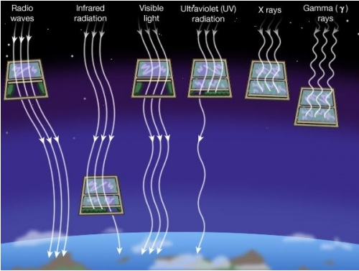](https://climate.ncsu.edu/images/edu/atmwindow.jpg)**  
Figure A: The Atmospheric Window (Image from Penn State University)

Shortwave radiation (visible light) contains a lot of energy; longwave radiation (infrared light) contains less energy than shortwave radiation (shortwave radiation has a shorter wavelength than longwave radation). Solar energy enters our atmosphere as shortwave radiation in the form of ultraviolet (UV) rays (the ones that give us sunburn) and visible light.  The sun emits shortwave radiation because it is extremely hot and has a lot of energy to give off.  Once in the Earth’s atmosphere, clouds and the surface absorb the solar energy.  The ground heats up and re-emits energy as longwave radiation in the form of infrared rays.  Earth emits longwave radiation because Earth is cooler than the sun and has less energy available to give off.

**Solar Irradiance Detection:**

<https://www.nasa.gov/mission_pages/sdo/science/solar-irradiance.html>

Total Solar Irradiance (TSI) is the main contributor of energy to Earth. We are fortunate that visible and IR light, which contribute the majority of energy to Earth, exhibit the smallest relative variation. But, although TSI varies by only a fraction of a percent, it has the greatest magnitude of change. This may be enough to cause observable changes at Earth.

Visible light and infrared radiation reach the surface, warming the surface to livable conditions. Ultraviolet radiation in the UV-A, B, and C wavelengths is absorbed at higher and higher altitudes. Extreme ultraviolet and soft X-ray radiation (wavelengths less than 120 nm, EUV) is absorbed by the atmosphere above 60 miles. Although it is completely absorbed by our atmosphere, EUV radiation is quite dangerous to people and electronics in space.

Each part of the solar irradiance changes over the 11-year solar cycle, becoming brighter than average at solar maximum and dimmer at solar minimum. Each wavelength also changes as the Sun rotates and during solar flares. Changes seen at the Earth are not the same as those at the other planets.

To understand the mechanisms that cause EUV irradiance variations, two sets of measurements are required. Measurements of the EUV spectral irradiance over a wide range of wavelengths at a rapid cadence. Next, images of the Sun at the same wavelengths to identify the sources of the radiation. The EVE and AIA instruments will provide these complementary measurements.

<http://lasp.colorado.edu/home/maven/science/instrument-package/lpw/extreme-ultraviolet-euv-monitor/>

The Extreme Ultraviolet (EUV) monitor is an instrument on the NASA Mars Atmosphere and Volatile EvolutioN (MAVEN) mission, designed to measure the variability of the solar soft x-rays and EUV irradiance at Mars.

<http://lasp.colorado.edu/home/missions-projects/quick-facts-sdo-eve/>

With the exception of the slow evolutionary changes in solar structure over the last 4.5 billion years, almost all solar variability is magnetic in origin. The solar cycle is a magnetic cycle in which the Sun’s magnetic poles reverse with a periodicity of approximately 11 years (SOLAR CYCLE) and intense magnetic fields erupt through the surface in sunspots whose numbers wax and wane with the cycle. Solar flares and coronal mass ejections occur when magnetic fields are stressed beyond their limits. The very structure of the corona and the solar wind is determined by the structure of the magnetic field. The heating of the Sun’s corona and the acceleration of the solar wind are thought to be due to interaction between small-scale magnetic elements.

**Air Pollution EnvironmentalArticle, Keypoints:**

<http://www.ccacoalition.org/en/news/world-health-organization-releases-new-global-air-pollution-data>

**Key findings:**

* WHO estimates that around 90% of people worldwide breathe polluted air. Over the past 6 years, ambient air pollution levels have remained high and approximatively stable, with declining concentrations in some part of Europe and in the Americas.
* The highest ambient air pollution levels are in the Eastern Mediterranean Region and in South-East Asia, with annual mean levels often exceeding more than 5 times WHO limits, followed by low and middle-income cities in Africa and the Western Pacific.
* Africa and some of the Western Pacific have a serious lack of air pollution data. For Africa, the database now contains PM measurements for more than twice as many cities as previous versions, however data was identified for only 8 of 47 countries in the region.
* Europe has the highest number of places reporting data.
* In general, ambient air pollution levels are lowest in high-income countries, particularly in Europe, the Americas and the Western Pacific. In cities of high-income countries in Europe, air pollution has been shown to lower average life expectancy by anywhere between 2 and 24 months, depending on pollution levels.

#### WHO’s Ambient air quality database

**Website for various types of satellite missions and data sets:**

<https://earth.esa.int/web/guest/data-access/browse-data-products>

**Alternatives to Satellites:**

<https://www.researchgate.net/publication/268571556_Material_Challenges_for_Lighter-Than-Air_Systems_in_High_Altitude_Applications>

A stratospheric airship can offer a cost-effective alternative to earth-orbit satellites for acquiring unique data sets related to telecommunications and science. Some advan- tages of high-altitude airship over satellites are as follows [2,4,9] In LTA systems, the envelope is one of the major structural parts and contains lifting gas such as helium, maintaining its aerodynamic shape. During their service life, the LTA systems are exposed to various envi- ronmental conditions such as UV rays from sunlight, ozone, temperature variation (heat or cold), atmospheric pressure variation, rain, moisture, pollutants, etc., causing degradation of the materials used in the envelopes. ...

<https://www.forbes.com/sites/startswithabang/2018/02/06/sorry-earth-the-ozone-layer-isnt-healing-itself-after-all/#1d952f615418>

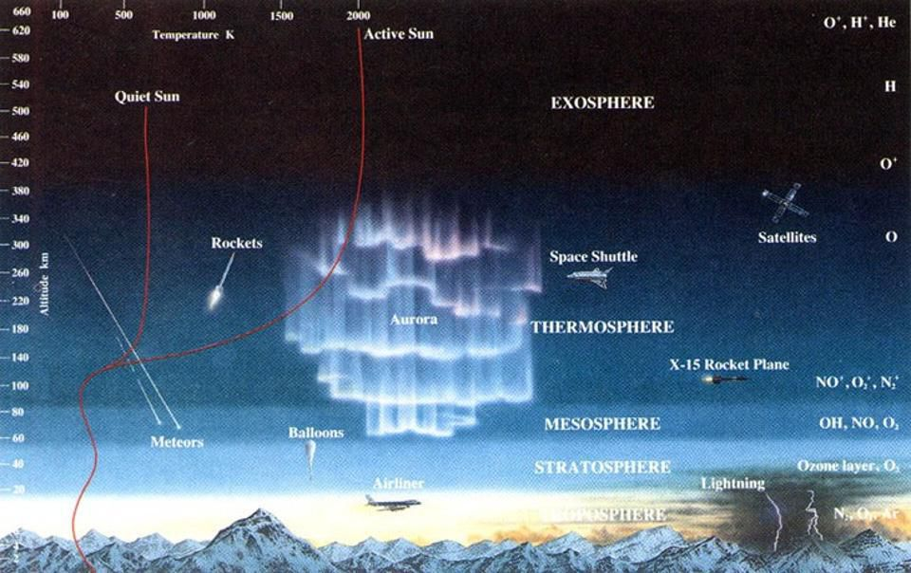

**Ultraviolet radiation is known to be dangerous, and our stratospheric ozone is our first line of defense.**

<https://www.atmos-chem-phys-discuss.net/acp-2017-862/acp-2017-862.pdf>

<https://www.eea.europa.eu/themes/climate/ozone-depleting-substances-and-climate-change/protecting-the-ozone-layer-while>

**Helium filled air ships ozone repair:**

<http://dailybruin.com/1996/08/18/helium-filled-airships-hope-in/>

**Ozone repair-Ozonator:**

<https://essuir.sumdu.edu.ua/bitstream/123456789/7975/1/2.pdf>

# **Earth's ozone layer is healing from aerosol damage: UN**

<https://www.ctvnews.ca/sci-tech/earth-s-ozone-layer-is-healing-from-aerosol-damage-un-1.4163438>

**Deployment of Strato-Airships and Aerostats:**

<http://kiss.caltech.edu/final_reports/Airship_final_report.pdf>

**500kg payload Aerostat:** <https://www.lockheedmartin.com/en-us/products/unmanned-aerostats-airships-and-lighter-than-air-technology.html>

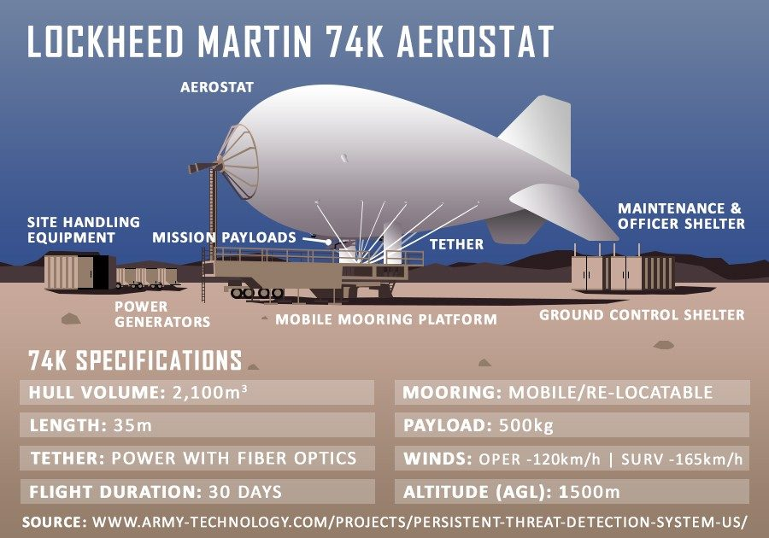

**Aerostat Injection System/SRM technology/Engineered Aerosols:**

<https://royalsocietypublishing.org/doi/pdf/10.1098/rsta.2011.0639>

The lead time required for implementation of any injection system is a particularly important criterion if the real value of SRM options is to provide an insurance policy against global warming and its effects: rising greenhouse gas concentrations may trigger significant transients such as runaway methane emission from melting arctic permafrost, major acceleration of ice sheet melting, or methane clathrate release from the ocean floor. Should any of these ‘tipping points’ be encountered then immediate measures will be required to reduce global temperature quickly in order to avoid unprecedented social, environmental and economic costs.

<https://arxiv.org/abs/1402.6706>

The "Airships: A New Horizon for Science" study at the Keck Institute for Space Studies investigated the potential of a variety of airships currently operable or under development to serve as observatories and science instrumentation platforms for a range of space, atmospheric, and Earth science. The participants represent a diverse cross-section of the aerospace sector, NASA, and academia. Over the last two decades, there has been wide interest in developing a high altitude, stratospheric lighter-than-air (LTA) airship that could maneuver and remain in a desired geographic position (i.e., "station-keeping") for weeks, months or even years. Our study found considerable scientific value in both low altitude (< 40 kft) and high altitude (> 60 kft) airships across a wide spectrum of space, atmospheric, and Earth science programs. Over the course of the study period, we identified stratospheric tethered aerostats as a viable alternative to airships where station-keeping was valued over maneuverability. By opening up the sky and Earth's stratospheric horizon in affordable ways with long-term flexibility, airships allow us to push technology and science forward in a project-rich environment that complements existing space observatories as well as aircraft and high-altitude balloon missions.

Scientists at NASA's Jet Propulsion Lab in California think airships could aid them in research on astronomy and climate change and even be more capable than weather balloons.

<https://www.science.gov/topicpages/b/balloon+sonde+measurements>

Since few years, the French space agency CNES has developed boundary-layer pressurized balloons (BLPB) with the capability to transport scientific payloads at isopicnic level over very long distances and durations (up to several weeks in absence of navigation limits). However, the autonomy of conventional electrochemical concentration cell (ECC) ozone sondes, that are widely used for tropospheric and stratospheric soundings, is limited to few hours due to power consumption and electrolyte evaporation (owing to air bubbling in the cathode solution). In collaboration with the French research community, CNES has developed a new ozone payload suited for long duration flights aboard BLPB. The mechanical elements (Teflon pump and motor) and the electrochemical cell of conventional ECC sondes have been kept but the electronic implementation is entirely new. The main feature is the possibility of programming periodic measurement sequences -- with possible remote control during the flight. To increase the ozone sonde autonomy, a strategy has been adopted of short measurement sequences (typically 2-3 min) regularly spaced in time (e.g. every 15 min, which is usually sufficient for air quality studies). The rest of the time, the sonde is at rest (pump motor off). The response time of an ECC sonde to an ozone concentration step is below one minute. Consequently, the measurementsequence is typically composed of a one-minute spin-up period after the pump has been turned on, followed by a one- to two-minute acquisition period. All time intervals can be adjusted before and during the flight. Results of a preliminary ground-based test in spring 2012 are first presented. The sonde provided correct ozone concentrations against a reference UV analyzer every 15 minutes during 4 days.

**Thermal and IR satellite accuracy**

[**http://www2.hawaii.edu/~jmaurer/sst/**](http://www2.hawaii.edu/~jmaurer/sst/)

**Thermal and IR satellite accuracy on Total Solar Irradiance**

[**http://science.jrank.org/pages/6875/Total-Solar-Irradiance.html**](http://science.jrank.org/pages/6875/Total-Solar-Irradiance.html)

[**http://lasp.colorado.edu/home/sorce/instruments/tim/**](http://lasp.colorado.edu/home/sorce/instruments/tim/)

**Troposphere Definition: Lower Atmosphere Definition**

[**https://en.m.wikipedia.org/wiki/Troposphere**](https://en.m.wikipedia.org/wiki/Troposphere)

**OCO-2 Co2 measurability instrument accuracy**

[**https://ocov2.jpl.nasa.gov/observatory/instrument**](https://ocov2.jpl.nasa.gov/observatory/instrument)

[**https://www.esrl.noaa.gov/gmd/ccgg/about/co2_measurements.html**](https://www.esrl.noaa.gov/gmd/ccgg/about/co2_measurements.html)

**AIRS/AMSU accuracy**

[**https://airs.jpl.nasa.gov/data/product_accuracies**](https://airs.jpl.nasa.gov/data/product_accuracies)

**AIRS/AMSU validity**

[**https://airs.jpl.nasa.gov/data/validation**](https://airs.jpl.nasa.gov/data/validation)

**Measuring Aerosol with Radiometer**

[**https://airs.jpl.nasa.gov/data/validation**](https://airs.jpl.nasa.gov/data/validation)

[**https://www.esrl.noaa.gov/gmd/aero/instrumentation/instrum.html**](https://www.esrl.noaa.gov/gmd/aero/instrumentation/instrum.html)

**Measuring Surface Temperatures:**

[**https://data.giss.nasa.gov/gistemp/**](https://data.giss.nasa.gov/gistemp/)

**New study question accuracy of Satellite measurements of atmospheric Temperatures:**

<https://www.google.com/amp/s/amp.theguardian.com/environment/climate-consensus-97-per-cent/2014/nov/07/new-study-disputes-satellite-temperature-estimates>

**Deep space satellite:** NOAA’s Deep Space Climate Observatory (DSCOVR) orbits one million miles from Earth. It provides space weather alerts and forecasts while also monitoring the amounts of solar energy absorbed by Earth every day. DSCOVR also makes observations about ozone and aerosols in Earth’s atmosphere. These factors are important in making air quality forecasts.

<https://scijinks.gov/forecast-reliability/>

**DSCOVR Satellite Radiometer irradiance measurably:**

<https://www.nesdis.noaa.gov/sites/default/files/asset/document/dscovr_nistar_instrument_info_sheet.pdf>

**Aerosols Nasa Article:**

[**https://earthobservatory.nasa.gov/features/Aerosols**](https://earthobservatory.nasa.gov/features/Aerosols)